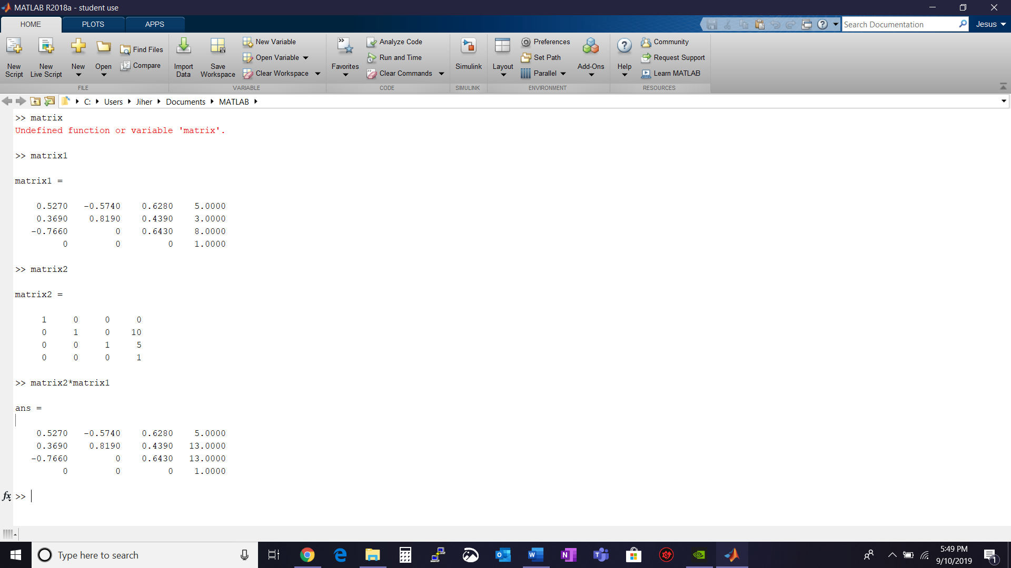

>> matrix1

matrix1 =

0.5270 -0.5740 0.6280 5.0000

0.3690 0.8190 0.4390 3.0000

-0.7660 0 0.6430 8.0000

0 0 0 1.0000

>> matrix2

matrix2 =

1 0 0 0

0 1 0 10

0 0 1 5

0 0 0 1

>> matrix2\*matrix1

ans =

0.5270 -0.5740 0.6280 5.0000

0.3690 0.8190 0.4390 13.0000

-0.7660 0 0.6430 13.0000

0 0 0 1.0000

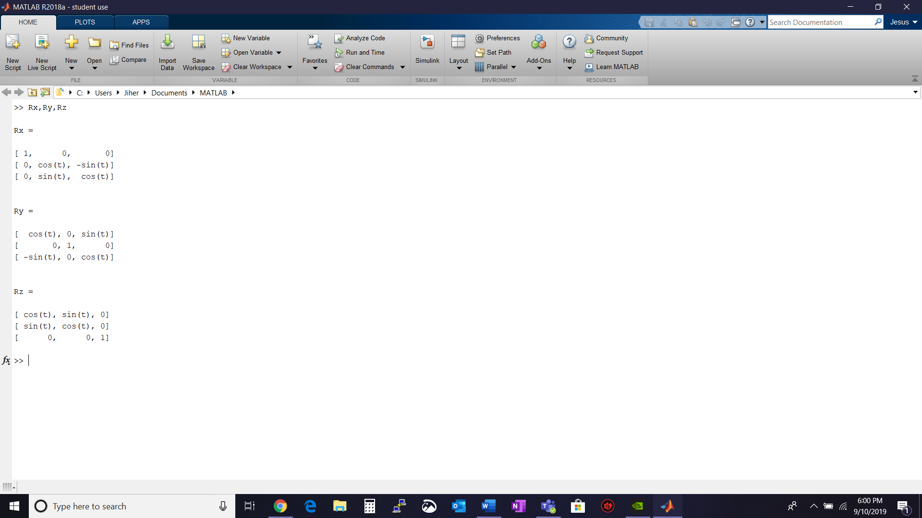

>> Rx,Ry,Rz

Rx =

[ 1, 0, 0]

[ 0, cos(t), -sin(t)]

[ 0, sin(t), cos(t)]

Ry =

[ cos(t), 0, sin(t)]

[ 0, 1, 0]

[ -sin(t), 0, cos(t)]

Rz =

[ cos(t), sin(t), 0]

[ sin(t), cos(t), 0]

[ 0, 0, 1]